**ARTIFICIAL INTELLIGENCE TECHNIQUES IN DRONES**

To reduce the human intervention in data we need to make **intelligent drones** that can **read**, **calculate**, **analyze**and **predict** data themselves to provide useful information. Without Humans, drones can rely on the in-built machine learning algorithms to function.

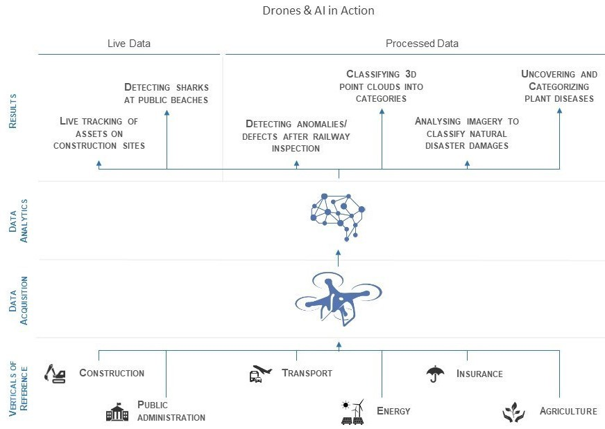

One example of this kind of process is, let us assume that we need to teach the drones like a toddler. so, How we teach a toddler? We show them the object (like an apple) and tell them its’ name, “Apple”. Now, we need to repeat this process again and again until the toddler remembers the object and its’ name. Similarly, a simple Machine learning technique is ‘**supervised learning**’ in this technique we can take loads of drones’ footages (dataset of drone’s images) and label them. In object detection models we can pass this dataset and the model can remember this labeled data. Now when we feed a new test image to the model, this model, on the basis of various features can predict the label of each object inside this given image.

These models are based on **deep neural networks** which in turn is dependent on **advanced probability & statistics** techniques.

**Better Obstacles Tackling:**

Drones can process sensor data and plan its way ahead by analysing the obstacles on its’ way. One of the famous Machine learning algorithms that can be used for this purpose is ‘**Fuzzy logic**’.

In simple terms, this algorithm will detect an object and can give a value (from 0 to 1) to all the possible labels for the object and the label with the highest value will be the solution.

**Agricultural Possibilities:**

A Drone camera lens can zoom in on the yellow flower of a tomato seedling and use these images into an artificial intelligence algorithm that predicts precisely how long it will take for the blossom to become a ripe tomato ready for picking, packing, and the produce section of a grocery store.

Drones can reportedly leverage computer vision to monitor and spray weeds on plants. Precision spraying can help**prevent herbicide resistance**. Precision technology eliminates 80 percent of the volume of chemicals normally sprayed on crops and can reduce herbicide expenditures by 90 percent.

Companies are leveraging**deep-learning pattern recognition algorithms** to process data captured by drones to monitor crop and nutrient deficiencies in the soil. An analysis is conducted by software algorithms which correlate particular foliage patterns with certain soil defects, plant pests, and diseases.

**Search & Rescue:**

Drones with efficient Machine learning algorithms can analyze the images of area by themselves and only send humans the images that have particular search object. For instance, a team of humans cannot keep an eye on video footage received from hundreds of drones in real time to find a missing vehicle. However, with AI, the smart algorithm can analyze the footage received from different cameras and identify the searched object in real time.

**Unmanned surveillance in dangerous warzones:**

As we know that AI describes the capability of machines that have characteristics of human intelligence and can perform sophisticated tasks like reasoning, problem-solving, planning and learning. **AI-powered armed drones** can identify the target by themselves with the help of thermal imaging cameras and can attack them without human intervention.

Japanese companies called **T-Frend** which is “**designed to reduce overtime by flying around the office after hours**, playing loud music and taking pictures of any staff who are still working and reporting them to management”. They can also explore the galaxy beyond the reach of timely communications from Earth in swarms of small space probes.

Further utilization and development of these powerful intelligent data processing tools will help in greatly reducing the processing time of big data, which is a huge challenge today. So we can conclude that, as AI applications in the drone industry are gaining importance, **highly automated flights** will become more feasible and more common.

**How to build a 5G drone using AI**

* 4G LTE and/or 5G cellular technology are necessary for flying outside of visual line of sight. If you want your drone to run on a 5G network, you'll need to buy a new one or retrofit your present one, just as you would with a smartphone. A 5G-compatible modem is required for new 5G drones.
* A virtual private network (VPN) is required for security and multi-device networking.
* Simultaneous Localization and Mapping (SLAM) helps orient the drone to its ever-changing surroundings, as well as deep learning object recognition and integrated depth sensing to build mission paths and make obstacle avoidance easier.
* Use visual inertial odometry to determine device position (VIO).
* A flexible software architecture is utilized to make development easier.
* For simultaneous 4K video capture, streaming, and computer vision processing, several image sensors are supported.
* On a single printed circuit board, a lightweight, cost-effective, plug-and-play device with a substantial computing capability (PCB).

**Application of drones with AI**

1. **Automatic Flying Machines:**

For obvious reasons, computer vision is a much-discussed topic of artificial intelligence in the drone sector. For starters, numerous manufacturers already use powerful computer vision to keep drone pilots out of trouble: certain DJI drones, for example, have a capability that detects an obstruction and automatically figures out a route around it.

Many of the more advanced drone applications, such as urban deliveries and aerial mobility systems, will necessitate additional breakthroughs in computer vision and danger awareness, which is why this is an area of significant R&D. AlphaPilot, a drone racing competition with a twist, is one noteworthy initiative demonstrating advancements in this area. The Drone Racing League (DRL) is organizing the event, which is sponsored by Lockheed Martin.

The goal is to publicize DRL's new Artificial Intelligence Robotic Racing Circuit on the surface. Beyond that, there's a push to investigate and create AI pilots that can keep up with their human counterparts.

### ****Easy Surveillance:****

Drones may be outfitted with a variety of surveillance devices to gather HD video and still photographs at all hours of the day and night. Drones may be outfitted with equipment that allows them to listen in on phone calls, track GPS movements, and collect license plate data. The high payload compatibility enables the use of a variety of surveying instruments, including lidar scanners, multi- and hyperspectral sensors, and much more, 24 hours a day, with little labor and expenditures.

Drone surveillance allows for the collecting of information about a target from a distance or height while remaining undetected. Drone surveillance allows for the covert collection of information about a target from a distance or height.

Of fact, drone utilization in this broad business (or area) goes well beyond these basic and uncomplicated parameters. Drone technology is used by government authorities, police, and other security professionals. As firms and researchers discover new methods to utilize machine learning to evaluate live video data, automated monitoring will become more ubiquitous.

For example, A recent experiment led by scientists in the United Kingdom and India demonstrates one prospective application for this technology: using camera-equipped drones to detect aggressive behavior in crowds. It employs a cheap Parrot AR quadcopter to broadcast video footage for real-time analysis through a mobile internet connection. The stances of persons in the film are estimated by a deep learning system, which matches them to "violent" postures identified by the researchers. Strangling, punching, kicking, shooting, and stabbing are the only five positions included in the project.

### ****Heritage protection:****

With the terrible fire at Notre Dame Cathedral in Paris making international news, it's encouraging to know that drone technology was on the scene to assist firefighters and prevent the inferno from spreading further. The focus now shifts to the reconstruction and restoration procedure. Drones and artificial intelligence are already being used in similar projects. Iconem, a French company, is at the forefront of this industry. Iconem, a company founded by architect Yves Ubelmann, is creating new standards for 3D modeling and recording of historic structures.

Looting, urbanization, mass tourism, violence, and climate change are all threats to many people. As a result, preserving them has become a global concern. After all, these are the places where civilizations and civilisations began.

The goal is to conserve and safeguard world history, but the method is cutting-edge. Drones, advanced modeling techniques, and cloud computing are all combined in Iconem. As a consequence, scholars, restorers, and the general public may access extremely realistic and immersive representations of key historical sites. Iconem has worked on restoration projects, exhibits, and virtual reality experiences, among other things.

Drones, admittedly, fall short of satellite imagery's accuracy in anticipating severe weather occurrences. They are, nonetheless, capable of offering crucial aid in the event of a tragedy. Government agencies and insurers are becoming more aware of the possibility of employing them to estimate post-disaster losses, particularly at places that have not been designated as safe for people to access.

Drones collecting air samples is a significant improvement over traditional data gathering methods, and it has the potential to greatly increase the accuracy of weather forecasting models. More accurate models have an impact on both the day-to-day and the long-term. It enables meteorologists to provide better 10-day weather predictions, but it also enables them to provide more early notice for events such as tornadoes, as well as if and where hurricanes will land.

Weather drones can collect critical data on temperature, moisture, air pressure, and wind speed and direction by flying across the whole vertical layer of the boundary layer of the atmosphere.

This data may be collected in a variety of ways using weather drones. Temperature, humidity, and air pressure sensors connected directly to the drone are one method. Dropping sensors called dropsondes from a high altitude with a parachute is another way they collect data. The dropsondes capture data as they fall through the vertical profile of the boundary layer. Visual imagery, such as images and video, is another key method of weather drones to acquire data.

## **Conclusion:**

Artificial Intelligence (AI) is a critical instrument in the technological industry. It is a boon for drone development when paired with a 5G network. Engineers who plan ahead rely on these advancements on a regular basis to improve drone capabilities and broaden use cases, making them smarter, safer, and more capable. We will learn about artificial intelligence in drone technology in this article.